21 December 2018
Dear Residents/Businesses,

Consultation update - Traffic management and road safety proposals in the Cavendish Drive/Scarborough Road area

We are writing to let you know the results of the recent public consultation on proposals for traffic management and road safety changes in your area that took place between Thursday 19th October and Thursday 8th November 2018. We received 113 responses to the consultation so thank you to everyone who provided feedback.

Below are the overall responses from the consultation:

Banned left turn restrictions from Grove Green Road into Scarborough Road, Southwest Road and Drayton Road

- 45.5% of respondents supported the introduction of the proposed banned left turn restrictions between 7am and 7pm
- 43.8% were not supportive of the proposals
- 10.7% had no strong opinion, did not know, or did not specify a response

Additional traffic calming measures in Cavendish Drive

- 62.5% of respondents supported the installation of additional traffic calming in Cavendish Drive.
- 17.0% were not supportive
- 20.5% had no strong opinion, did not know, or did not specify a response

Changes to the Cavendish Drive/Scarborough Road junction

- 59.0% of respondents supported the proposed changes to the Scarborough Road/Cavendish Drive junction.
- 20.5% were not supportive
- 20.5% had no strong opinion, did not know, or did not specify a response

We have analysed the feedback received on a road by road basis and while the additional traffic calming measures and Scarborough Road/Cavendish Drive junction changes were generally supported by all roads within the consultation area, feedback to the proposed left turn ban restrictions was much more varied. Only residents of Cavendish Drive, Scarborough Road and Hawbridge Road showed overall support for the proposed left turn ban restrictions with all other roads showing a majority against the restrictions.

Based on the feedback received to the consultation and our road by road analysis we are therefore proposing the following changes for the area:

- New 7am-7pm banned left turn restriction from Grove Green Road into Scarborough Road only. The restriction will operate Monday to Sunday and will be camera enforced. The proposed banned left turn restrictions from Grove Green Road into Southwest Road and Drayton Road will not be progressed at this time.

- An additional 7am-7pm banned left turn restriction from Southwest Road into Avebury Road. This will prevent vehicles from using Southwest Road and Avebury Road to access Cavendish Drive and bypass the banned left turn restriction at the Grove Green Road/Scarborough Road junction. The restriction will operate Monday to Sunday and will be camera enforced

- An additional traffic calming measure in Cavendish Drive as per the consultation proposals.

- Two additional traffic calming measures in Drayton Road, in response to concerns over vehicle speeds in the road.

We are still investigating whether a 7.5 Tonne lorry ban can be introduced and effectively enforced, and will update residents once we have further information on this.

Many respondents chose to leave additional comments to support their consultation response, with the vast majority focusing on the proposed banned left turn restrictions and general traffic conditions in the area. A range of issues and concerns were raised about both current traffic conditions and the proposed changes and a number of suggestions for alternative and additional measures were also put forward.
The proposals set out in the consultation were identified as options that could be introduced with localised consultation and in a relatively short timeframe in response to the issues and concerns being raised from the area. They also sought to strike a balance between deterring through traffic while maintaining local access for residents and businesses as far as possible. It is acknowledged that some respondents do not feel that the measures go far enough and will not address all the problems being experienced, and that suggestions for alternatives such as one-way restrictions, road closures, and re-opening roads in adjacent areas have been put forward as a consequence.

The proposals outlined in this letter are seen as an initial set of measures to be delivered in the area and will be monitored closely following implementation to assess their impact and to determine whether further measures, such as some of those suggested, should be considered as part of a subsequent stage. It is however worth highlighting that some of the suggestions made do represent more substantial changes to the area, which based on the council’s recent experiences delivering similar projects across the borough are likely to require a more significant engagement and consultation approach. They are also likely to take a longer time to develop and deliver, which is why the council opted to propose a more easily deliverable set of interim measures in the first instance to be as responsive as possible to the issues being experienced.

View the plans:

Please find the plans online at the following link and if you have any problems accessing the information or would like to request a printed copy please phone the Enjoy Team: 020 8496 1029

http://bit.ly/CavendishProposal

What happens next?

We will write to residents and businesses again in January to provide further details on the Traffic Management Order advertisement process, expected implementation dates and any temporary traffic management measures required to complete the works. We will also outline the monitoring process that we intend to put in place along with timescales for monitoring activities.
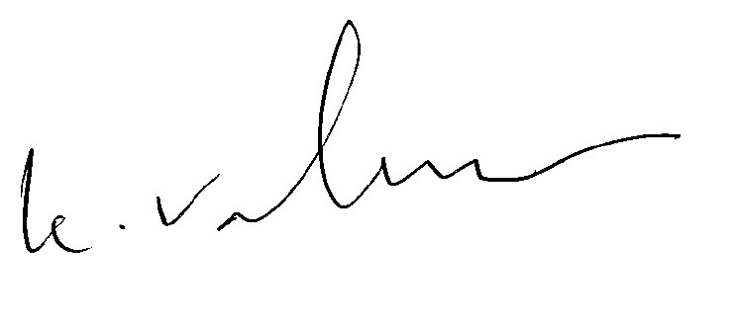

Vala Valavan
Director of Highways and Traffic Management

